David Lakes

MATH 200

Project 1

Professor Brown

Due Dec. 10, 2023

**Max (Tallest Woman) Information**

Value: 73.89 inches

Z-Score: 2.54

Probability of being taller: 0.00554262

Probability of being shorter: 0.99445738

The positive Z-Score is roughly 2.5 standard deviations higher than the mean of the data set. This woman would be within the tallest 1% of heights in a normal distribution.

The probability of a woman being taller than the tallest woman from the data set is less than 5%. This signifies that her height is unusual.

Probability of being taller:

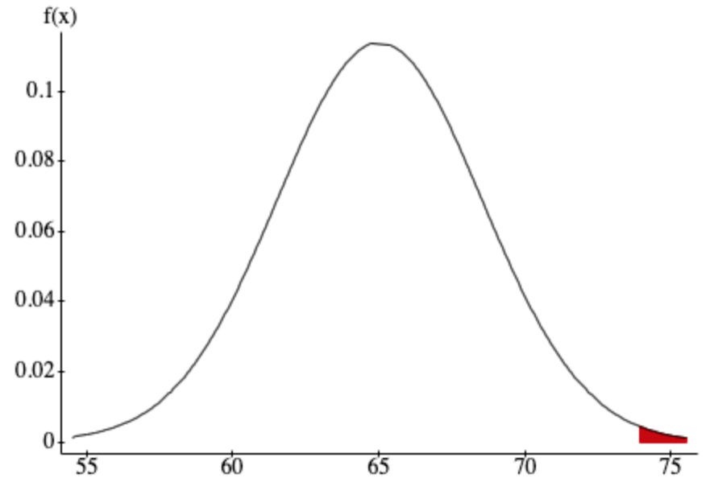

Probability of being shorter:

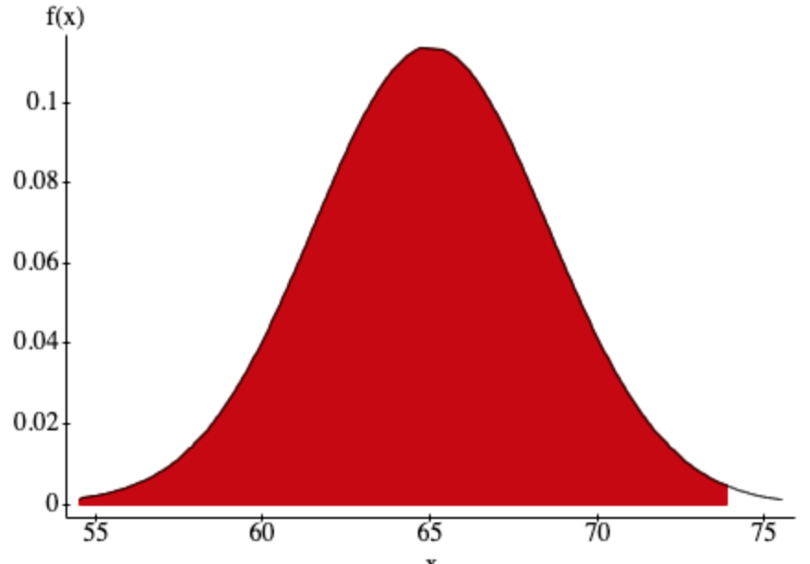

**Minimum (Shortest Woman) Information**

Value: 59.31 inches

Z-Score: - 1.6257

Probability of being shorter: 0.05200522

Probability of being taller: 0.94799478

The negative Z-Score is 1.6257 standard deviations lower than the mean of the data set. This woman is within the shortest 10% of the population.

The probability of a woman being shorter than the shortest woman from the data set is greater than 5%, meaning her height is not unusual.

Probability of being shorter:

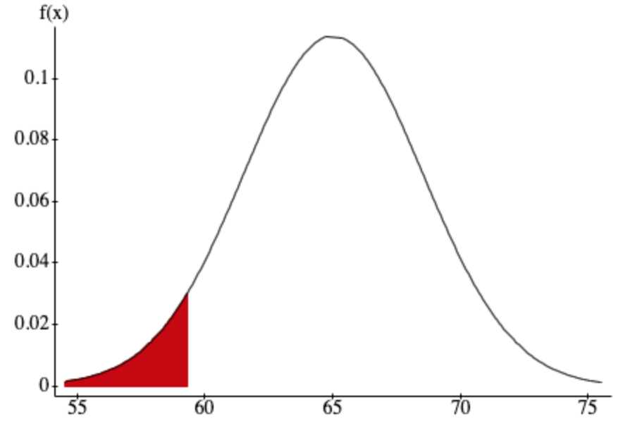

Probability of being taller:

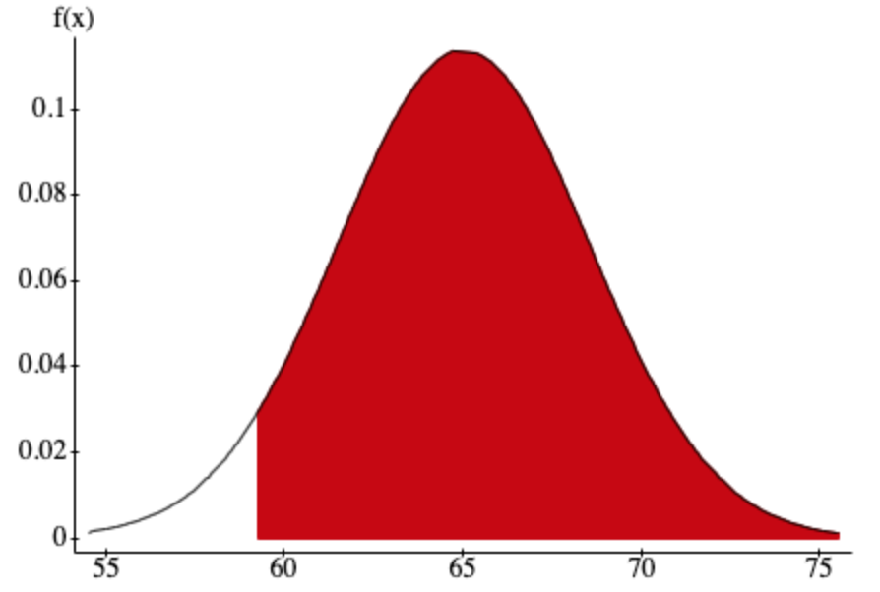

**Sampling Distribution of Mean**

The sample distribution is roughly symmetrical, but also has a slight skew to the left, indicating that the population mean may be slightly less tall than the sample mean.

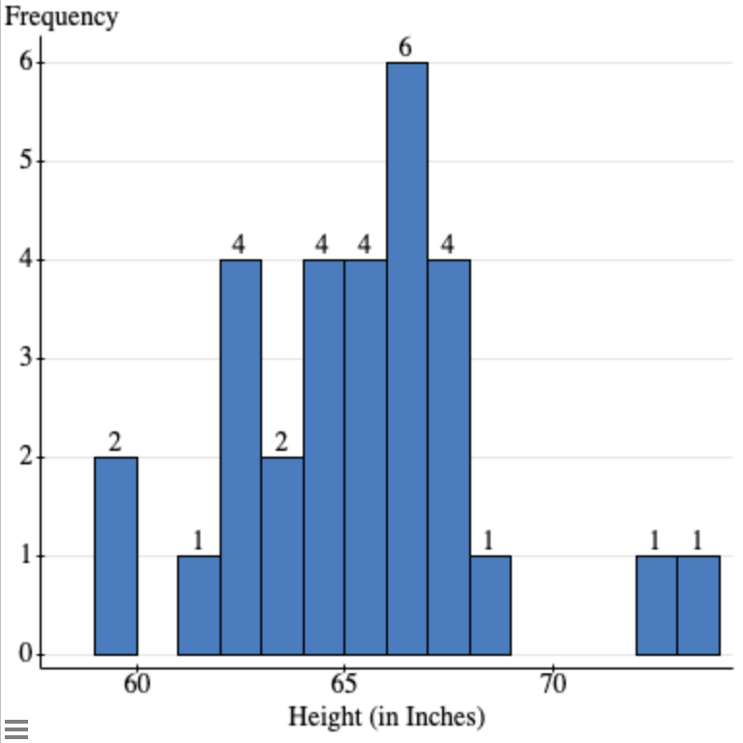

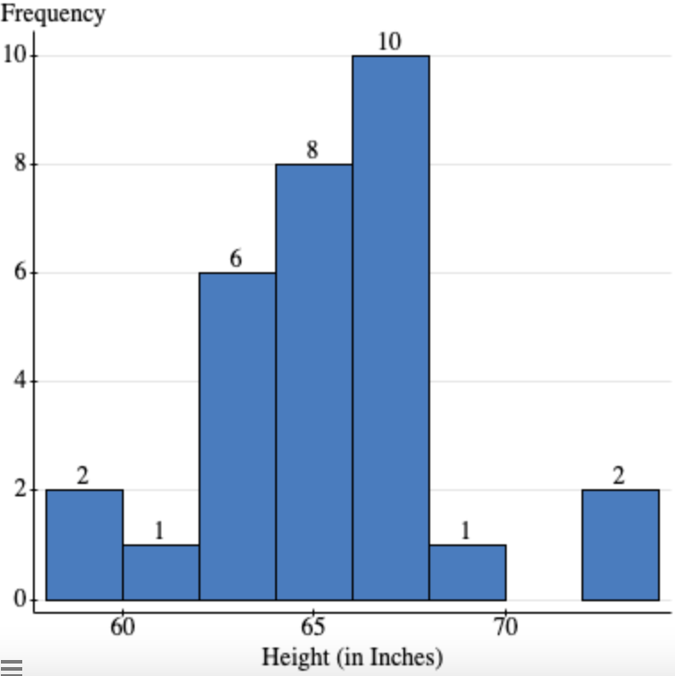

**Boxplot and Outliers**

The two tallest women in the sample set are considered to be outliers and are roughly between 4-6 inches above the upper-limit.

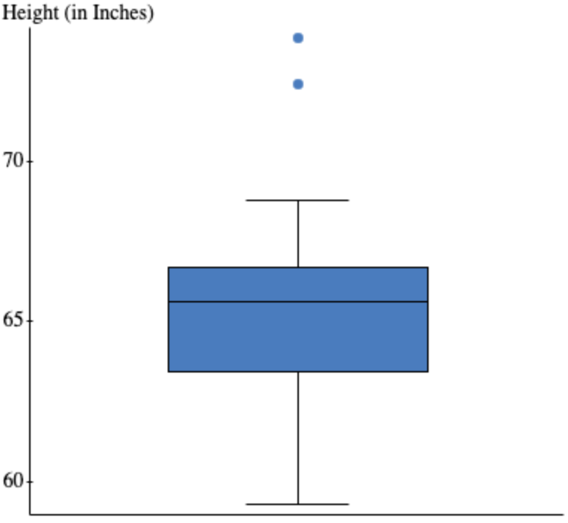

**Confidence Interval**

**One sample Z confidence interval:**

**Upper Limit: 66.51**

**Lower Limit: 64.27**

**One sample T confidence interval:**

**Upper Limit: 66.56**

**Lower Limit: 64.24**

The mean given before is between the confidence interval, so we are 95% confident that the mean is between the lower and upper limits. This supports what we were told about the mean.

**Female Volleyball Players**

The average height for female volleyball players (67 inches) is outside the 95% confidence interval, meaning female volleyball players are unusually tall.

**Female Soccer Players**

Our null hypothesis is that women are typically not significantly taller than the average female soccer player. Our test hypothesis is that women are typically significantly taller than the average woman.

**Results:**

**T-Stat: 2.99**

**P-Value: .0028**

The t-stat suggests that the average woman is nearly 3 standard deviations taller than the average female soccer player. The P-value is below the significance value (0.05), meaning we reject the null hypothesis as there is sufficient evidence that the average woman is significantly taller than the average female soccer player.